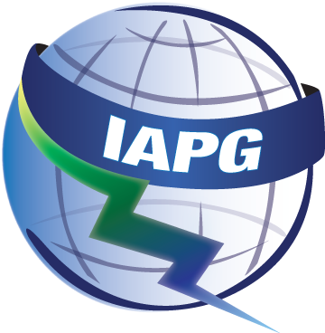
Sample Abstract Submission Instructions for the:
Interagency Advanced Power Group (IAPG)
Mechanical Working Group Meeting
May 12–14, 2026

“PRESENTATION TITLE”

Sample Author #1, Author Affiliation
Sample Author #2, Author Affiliation

To ensure the proper evaluation of abstracts submitted to the 2026 IAPG Mechanical Working Group (MWG) Meeting, all speakers for the TECHNICAL SESSION scheduled for May 14, 2026, are required to submit an abstract. Abstracts should be 1-2 paragraphs in length and should include the presentation title, speaker(s) full name and their affiliation, complete mailing address, phone number, and e-mail address.

It is recommended that justified Arial 11-point font be used for the body, Arial 14-point bold for the title, with surrounding one-inch margins. The presentation should be submitted in Microsoft PowerPoint or PDF format.

Please e-mail all abstract submissions to Renee O’Brokta at renee.obrokta@nasa.gov, no later than March 10, 2026. Further information about the 2026 MWG Meeting may be obtained by visiting the MWG page of the IAPG website at https://iapginfo.org/events/mwg-2026/.

Speaker/Presenter Contact Information:

Name
(as you would like it to appear on agenda)
Affiliation
Funding/Sponsoring Organization
Mailing Address
Telephone Number
E-mail address
If you have any restrictions on when you need to present, please list them here.

Please indicate the MWG Panel affiliation with this presentation:

Integrated Systems Panel
Power Conversion Panel
Nuclear Power Panel
Thermal Management Panel

